**Mid Term**



**Spring 2024**

**CSE-301L**

**Operating System Lab**

Submitted by: **NAVEED AHMAD**

Registration No.: **22PWCSE2165**

Class Section: **B**

“On my honor, as student of University of Engineering and Technology, I have neither given nor received unauthorized assistance on this academic work.”

Submitted to:

**DR. Safdar Nawaz Khan Marwat**

April 19, 2024.

Department of Computer Systems Engineering

University of Engineering and Technology, Peshawar

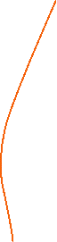

**QUESTION:**

**Task 1:**

Using for loop, remove the alphabetic portion of the registration number and display a message such as The numeric portion of the entered registration number is 2299883.

**Code:**

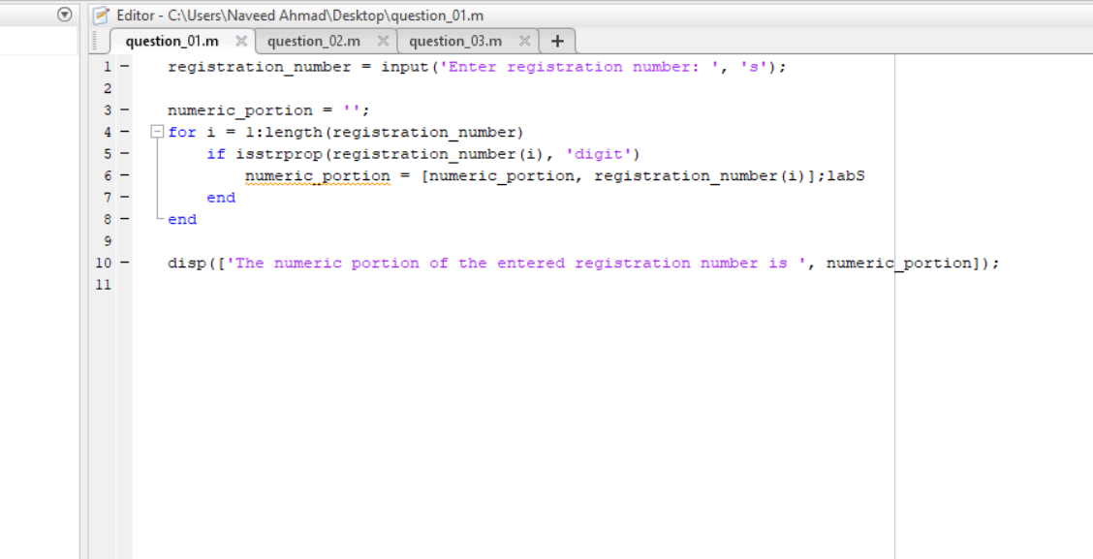

**Output:**

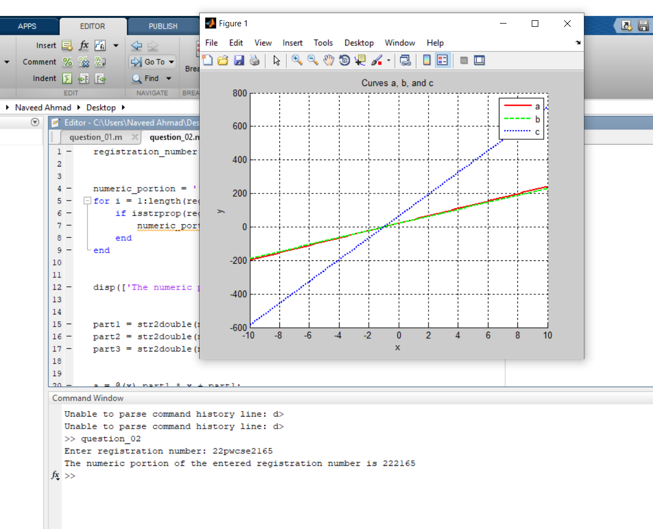

**Task 2:**

Split the registration number into three parts of two digits each. Use each part to create three curves a, b, c (e.g. a=2x+2, b=9x+9, c-8+8). Plot the three curves a, b, c on the same graph using different plot styles for the range -10 to 10.

**Code :**

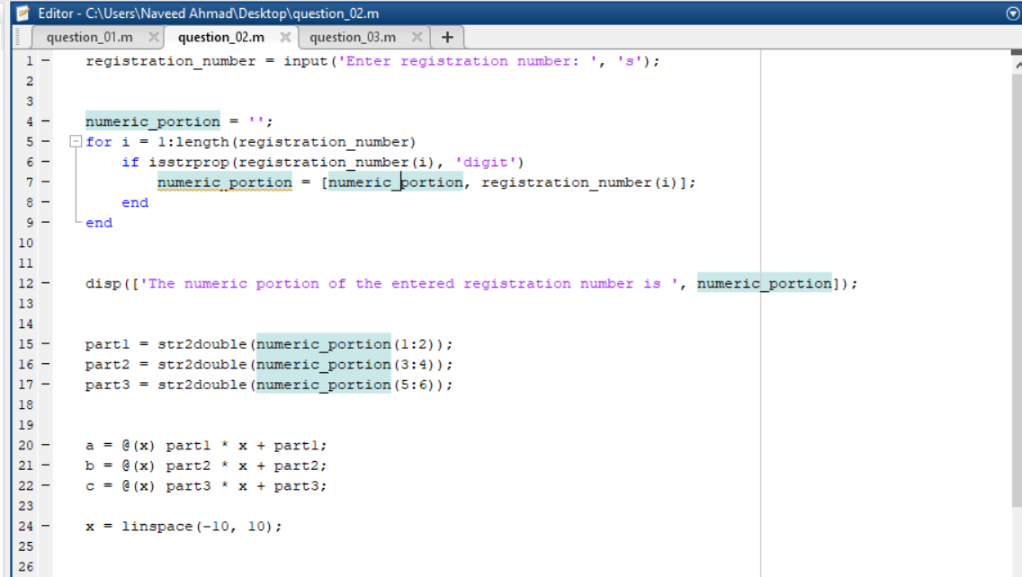

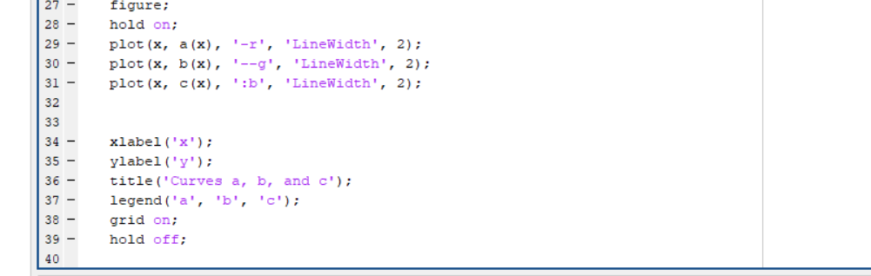

**Output:**



**Task 3:**

Change the range in part in. to [-15,15] and plot a, b, c again.

Code:

**Output:**

